**CCGC 5004 Database Systems**

**Lab Exercise 2 SELECT Statement on a Single Table**

**Overview**

**To receive credit for this lab you must be present in today’s class. Late submissions are deducted 5% per day up to 5 days. Submissions received after 5 days will be given a grade of 0.**

**In this exercise you will download and run a script to populate your schema with the tables needed to perform the required queries.**

**You will write and execute queries as requested in the questions below.**

**Section 1**

In Blackboard Lesson 2 there is a script file. Using your VM open the browser, Google Chrome is available, and login to your Blackboard account and download the script called **create_my_guitar_shop.sql and a second script called create_db_ap.sql.** Once you download the scripts, place them on the desktop in Windows. Use Blackboard to access your account. The scripts are loaded in Week 2.

Click on the script name.

Click on the three dots at the right side of the script name. Select Download Original File

Go to the Downloads page and move the files to t he Desktop.

**You have been assigned to a schema in your user account. Connect to MySQL Workbench with your user account. When you are connected to your schema enter the following to connect to your schema that has been created. My schema is called bill, your schema is your student number followed by F21. Enter that as follows and execute the command.**

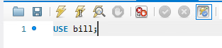

Load the script file into MySQL Workbench and execute the script. File > Open SQL Script, find the script and load into Workbench.

To execute the script, click the icon that is circled.

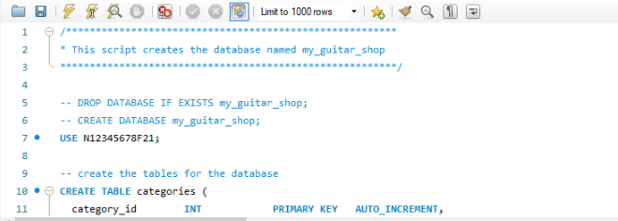

You will need to modify the USE statement, so it reflects the database that was created for you. It is the same as your user id for MySQL, the N number followed by F21

Execute the entire script by clicking the button indicated above.

This is what the schema will look like for my_guitar_shop.

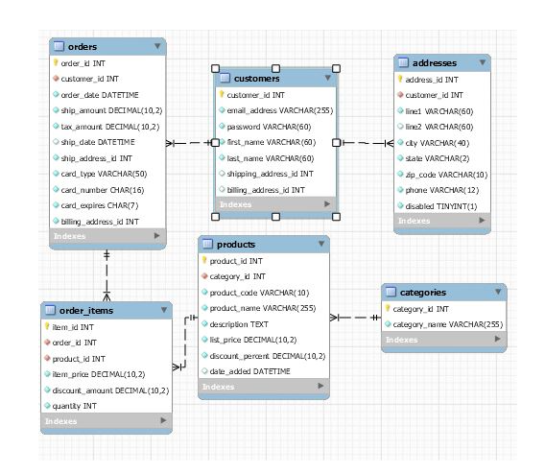

You are now ready to enter the queries for this exercise.

For each query you are to take a screen capture that will show the entire query and as much of the result window as you can show. You are to label each screen capture as indicated.

**Section 2**

1. Write a SELECT statement that returns four columns from the Products table: product_code, product_name, list_price, and discount_percent. Then, run this statement to make sure it works correctly.

Add an ORDER BY clause to this statement that sorts the result set by list price in descending sequence. Then, run this statement again to make sure it works correctly. This is a good way to build and test a statement, one clause at a time. **Screen Capture 1**.

1. Write a SELECT statement that returns one column from the Customers table named full_name that joins the last_name and first_name columns.

Format this column with the last name, a comma, a space, and the first name like this:

Doe, John

Sort the result set by the last_name column in ascending sequence.

Return only the customers whose last name begins with letters from M to Z.

NOTE: When comparing strings of characters, ‘M’ comes before any string of characters that begins with ‘M’. For example, ‘M’ comes before ‘Murach’. **Screen Capture 2**

1. Write a SELECT statement that returns these columns from the Products table:

product_name The product_name column

list_price The list_price column

date_added The date_added column

Return only the rows with a list price that’s greater than 500 and less than 2000.

Sort the result set by the date_added column in descending sequence. **Screen Capture 3**.

1. Write a SELECT statement that returns these column names and data from the Products table:

product_name The product_name column

list_price The list_price column

discount_percent The discount_percent column

discount_amount A column that’s calculated from the previous two columns

discount_price A column that’s calculated from the previous three columns

Round the discount_amount and discount_price columns to 2 decimal places.

Sort the result set by the discount_price column in descending sequence.

Use the LIMIT clause so the result set contains only the first 5 rows. Label **as Screen Capture 4**

1. Write a SELECT statement that returns these column names and data from the Order_Items table:

item_id The item_id column

item_price The item_price column

discount_amount The discount_amount column

quantity The quantity column

price_total A column that’s calculated by multiplying the item price by the quantity

discount_total A column that’s calculated by multiplying the discount amount by the quantity

item_total A column that’s calculated by subtracting the discount amount from the item price and then multiplying by the quantity

Only return rows where the item_total is greater than 500.

Sort the result set by the item_total column in descending sequence. Label as **Screen Capture 5**.

1. Write a SELECT statement that returns these columns from the Orders table:

order_id The order_id column

order_date The order_date column

ship_date The ship_date column

Return only the rows where the ship_date column contains a null value. Label as **Screen Capture 6**.

1. Write a SELECT statement without a FROM clause that uses the NOW function to create a row with these columns:

today_unformatted The NOW function unformatted

today_formatted The NOW function in this format:   
DD-Mon-YYYY

This displays a number for the day, an abbreviation for the month, and a four-digit year. (**Screen Capture 7**)

1. Write a SELECT statement without a FROM clause that creates a row with these columns:

price 100 (dollars)

tax_rate .07 (7 percent)

tax_amount The price multiplied by the tax

total The price plus the tax

To calculate the fourth column, add the expressions you used for the first and third column. (**Screen Capture 8**)

1. Write a SELECT statement that will display addresses from the addresses table. Display only addresses that are in NY or NJ or CA. Show the customer id, the City, State, and Zip Code columns. Display the results so they are sorted by State, then by City is ascending sequence. (**Screen Capture 9**)
2. Write a SELECT statement that will display customers that have an email address that uses yahoo.com.

Display the email address, the customers first initial, followed by a space then the last name. Show the heading for this column as Customer. Display the results is ascending sequence. (**Screen Capture 10**)